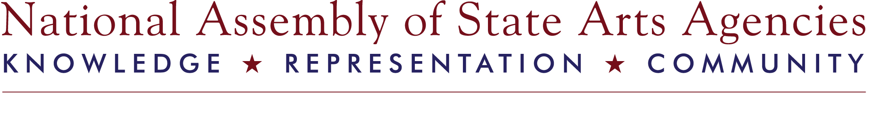
State Arts Agency Arts Education Managers
New Manager SWOT (Strengths, Weaknesses, Opportunities and Threats) Analysis

Adapted from Mentoring: A Henley Review of Best Practice, by Jane Cranwell-Ward, Patricia Bossons and Sue Gover

While filling out the form, please reference State Arts Agency Arts Education Manager Skill Domains and Core Competencies to inform your responses.

The skill domains for an arts education manager include: Administration; Advocacy; Communications; Community-Based Learning; Development and Fundraising; Evaluation and Assessment; Human Development and Educational Psychology; Human and Inter-Cultural Understanding; Intrapersonal and Artistic; Leadership and Partnership; Policy Formulation, Implementation, Analysis and Evaluation; Public School and Other Education Systems; Technology

List the strengths that you are bringing to the arts education position at your agency:

When reviewing the skill domains, what do you feel are your weaknesses or areas in which you need professional development?

Where do you see opportunities for your growth as an arts education manager or as an artist (if applicable)?

What are the challenges that you as an arts education manager face, or your programs may face in the upcoming years?

In reviewing your responses, what questions do you have for your mentor?

At the New Managers' Orientation or by phone, you and your mentor will identify goals and action steps to assist in your growth as an arts education manager.

