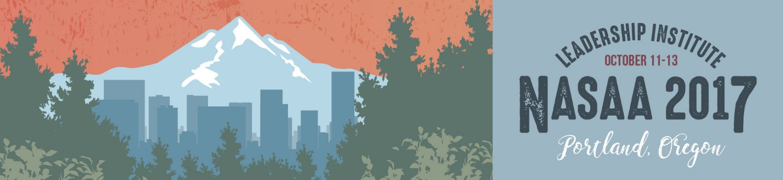

**Speaker Bios**

Plenary Session: Creating Connection & Building Public Will

Communications Clinics and Learning Expeditions

Plenary Session: National Endowment for the Arts

Peer Sessions, Part II: Crisis Leadership

Thursday, October 12

**Plenary Session: Creating Connection & Building Public Will**

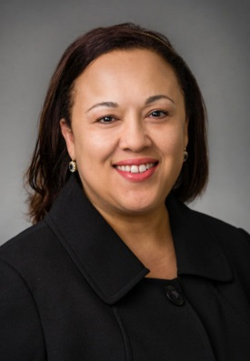**Pam Breaux, Chief Executive Officer**

**National Assembly of State Arts Agencies**

Pam Breaux joined NASAA as CEO in 2015. As chief executive officer, she works in collaboration with the NASAA board of directors to advance NASAA's federal policy agenda. A native of Lafayette, Louisiana, Pam has held leadership positions at the local, state and national levels. She most recently was assistant secretary of the Office of Cultural Development at the Louisiana Department of Culture, Recreation and Tourism (CRT). She is a former secretary of CRT and was executive director of the Louisiana Division of the Arts. During her time at CRT, Pam led Louisiana's cultural economy initiative and spearheaded the state's attainment of UNESCO recognition of Poverty Point as a World Heritage site. Before working in state government, Pam managed southwest Louisiana's Decentralized Arts Funding Program and was executive director of the Arts and Humanities Council of Southwest Louisiana. She has served on the boards of NASAA, South Arts, the Louisiana Board of International Commerce and the U.S. Travel Association. Pam is a member of UNESCO's U.S. National Commission. She graduated from McNeese State University with a B.A. in English, and has an M.A. in English and folklore from the University of Louisiana at Lafayette.

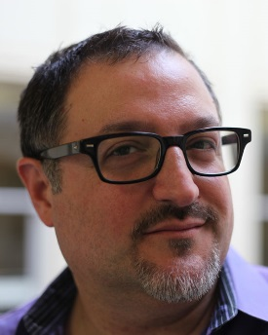**Eric Friedenwald-Fishman, Creative Director/Founder**

**Metropolitan Group**

Eric Friedenwald-Fishmanis one of the instigators of the Creating Connection Initiative. He is the Creative Director / Founder of Metropolitan Group, a leading social change consulting firm headquartered in Portland, Oregon, with offices in San Francisco, Washington, D.C., Chicago and Mexico City. Eric leads creative and strategy development and is a pioneer of Public Will Building (designing initiatives that shift normative societal expectations). Eric has worked extensively with leading foundations, nonprofit organizations, public agencies and social enterprise businesses to promote social equity, literacy, educational access, arts, heritage and culture. He has been a featured speaker at the National Endowment for the Arts's Education Leadership Institute, the Arts Education Partnership, and the Americans for the Arts national conference, and was the opening speaker and facilitator for America's first Arts and Environmental Summit. He is the coauthor of *Marketing That Matters* (Berrett & Koehler), which has been translated into six languages. Eric has served on the boards of numerous arts and cultural organizations and as a leadership volunteer for Arts Advocacy, and is the recipient of NWBCA's Exemplary Business Volunteer for the Arts award.

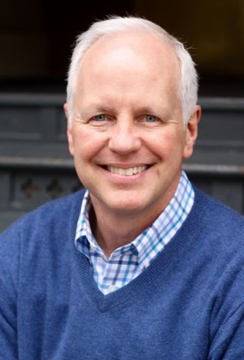**Kevin Kirkpatrick, Senior Executive Vice President**

**Metropolitan Group**

As the leader of Metropolitan Group's strategic communication practice, Kevin Kirkpatrick brings more than 27 years of experience in social marketing, public will building, issue framing, strategic planning, media relations and public policy advocacy to help clients achieve measurable, sustainable social change. Kevin is one of the leaders of Creating Connection, a national effort to build public will for the creative expression in all its forms, and has presented on this initiative before the NEA's Education Leadership Institute, Grantmakers in the Arts, Americans for the Arts and the National Guild for Community Arts Education. Kevin has served as Metropolitan Group's strategic director on work for the Illinois Arts Council, U.S. Regional Arts Organizations and the President's Committee on the Arts and the Humanities.

Thursday, October 12, continued

**Communications Clinics and Learning Expeditions**

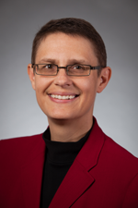**Kelly Barsdate, Chief Program and Planning Officer**

**National Assembly of State Arts Agencies**

Kelly Barsdate joined NASAA in 1991. She oversees NASAA's services to members, including all research activities, education programs and special initiatives. She runs NASAA's State Arts Agency Boot Camps, designs the association's web seminars and conferences, and conducts numerous workshops on topics such as cultural policy and funding trends, arts participation, public value, and practical evaluation methods. Kelly developed NASAA's New Directions in State Arts Agency Grantmaking curriculum, a series of workshops to help state arts agencies enhance the results of their grant investments. In addition to managing NASAA's internal strategic planning, Kelly often is engaged as a consultant to assist arts funders (both public and private) with strategic planning, program design, grant guidelines development and program evaluation. She has managed collaborations with partners including the National Governors Association, the National Conference of State Legislatures, the National Center for Charitable Statistics, Grantmakers in the Arts, The Pew Charitable Trusts, Princeton University, Altria and the National Endowment for the Arts. Kelly has authored numerous monographs and articles on arts funding and arts research. She is a frequent presenter at national arts and philanthropy conferences and is a contributing editor of the *Journal of Arts Management, Law and Society*.

**Pam Breaux, Chief Executive Officer**

**National Assembly of State Arts Agencies**

Pam Breaux joined NASAA as CEO in 2015. As chief executive officer, she works in collaboration with the NASAA board of directors to advance NASAA's federal policy agenda. A native of Lafayette, Louisiana, Pam has held leadership positions at the local, state and national levels. She most recently was assistant secretary of the Office of Cultural Development at the Louisiana Department of Culture, Recreation and Tourism (CRT). She is a former secretary of CRT and was executive director of the Louisiana Division of the Arts. During her time at CRT, Pam led Louisiana's cultural economy initiative and spearheaded the state's attainment of UNESCO recognition of Poverty Point as a World Heritage site. Before working in state government, Pam managed southwest Louisiana's Decentralized Arts Funding Program and was executive director of the Arts and Humanities Council of Southwest Louisiana. She has served on the boards of NASAA, South Arts, the Louisiana Board of International Commerce and the U.S. Travel Association. Pam is a member of UNESCO's U.S. National Commission. She graduated from McNeese State University with a B.A. in English, and has an M.A. in English and folklore from the University of Louisiana at Lafayette.

**Ben Brown, 1st Vice President, National Assembly of State Arts Agencies**

**Chair, Alaska State Council on the Arts**

Ben Brown has served on the Alaska State Council on the Arts since 2004, when he was appointed vice chairman, and since 2007 as chairman. A lifelong Alaskan and acting company member at Perseverance Theatre in Juneau, he has performed across the Last Frontier. Ben is an attorney who currently serves on the Alaska Commercial Fisheries Entry Commission, a state agency that oversees and implements the Alaska Limited Entry Act, which is dedicated to conservation and sustained-yield management of Alaska's unique fishery resources and supports economic stability for fishermen and their families. He was previously an associate attorney at Juneau's Baxter Bruce & Sullivan, P.C., with a diverse practice including both criminal and civil law. Ben worked as an aide in the Alaska legislature for many years before law school, and currently serves on the board of directors of Alaska Public Media, a statewide public broadcaster based in Anchorage. He previously served on the boards of the Alaska Humanities Forum, the Juneau Arts & Humanities Council, Capital Community Broadcasting (Juneau's public broadcaster), CoastAlaska (a consortium of Southeast Alaska public radio stations) and the Friends of the Alaska State Museum. Ben received his bachelor's degree from Georgetown University's School of Foreign Service and his juris doctor from Northeastern University School of Law.

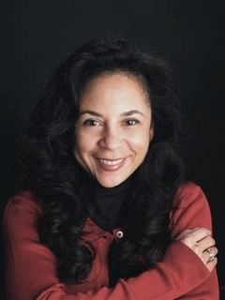**Kelly Brown, Director**

**D5 Coalition**

Kelly Brown is Director of the D5 Coalition, a five-year effort to advance philanthropy's diversity, equity and inclusiveness. Kelly has served as director of programs and evaluation at Marguerite Casey Foundation and as grants director at the Vanguard Public Foundation. She was director of marketing and industry relations at OpNet, a social venture that created digital work-force opportunities for low-income young adults, and was administrative director for TransAfrica/TransAfrica Forum, national foreign policy organizations at the forefront of efforts to secure a peaceful transition to a multiracial democracy in South Africa. Kelly has lived and studied in Nairobi, Kenya, where she conducted outreach, due diligence and fundraising to expand Kenya Women Finance Trust. She has an M.B.A. from the Haas School of Business at UC Berkeley and a B.A. in sociology and African/African American studies from UC Santa Barbara, and was a Sloan Foundation fellow at Princeton University's Woodrow Wilson School. Currently, she is pursuing a Ph.D. at the University of Chicago.

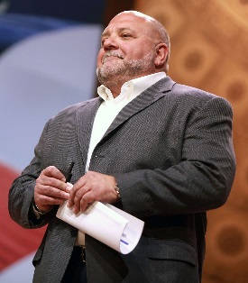**Tony Fabrizio, Partner**

**Fabrizio, Lee & Associates**

Tony Fabrizio, a partner in Fabrizio, Lee & Associates, is widely recognized as an expert in public opinion and politics and one of the nation's leading GOP pollsters and strategists. Tony has served as the chief pollster on four presidential campaigns, most notably and recently Donald Trump's successful 2016 upset victory. Over the years, Tony has helped elect more than two dozen U.S. senators, more than 50 members of Congress, numerous governors and other statewide elected officials, and has worked with dozens of issue groups and trade associations.

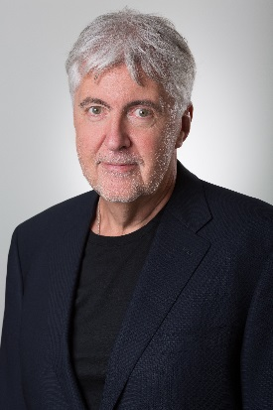**David Fraher, President & CEO**

**Arts Midwest**

For the past 40 years, David Fraher has directed his creative skill toward building and leading arts organizations and programs throughout the United States. In addition to working with the Western States Arts Federation, where he was instrumental in researching and designing the Western States Book Awards program, David enjoyed six years with the Wyoming Arts Council, where he held numerous positions, including executive director. In 1983 he joined what was then the Affiliated State Arts Agencies of the Upper Midwest as its executive director, and subsequently led its merger with Great Lakes Arts Alliance, creating Arts Midwest in 1985. He has been president and CEO of the organization since that time. In addition to his work at Arts Midwest, David currently serves on the board of the Alliance of Artists Communities. In 2007 he received the National Assembly of State Arts Agencies' Gary Young Award for contributions to public support for the arts, and in 2008 he received the National Endowment for the Arts Chairman's Medal for distinguished service to that agency. In 2012, he was given the Sally Ordway Irvine Award for efforts promoting arts access, and was selected as a fellow to the Salzburg Global Seminar. In 2014, he became only the second American to be awarded the Cultural Exchange Contribution Award by the People's Republic of China. David has a degree in creative writing from SUNY at Brockport, New York, and completed two years of graduate work in creative writing and American literature at Ohio University in Athens.

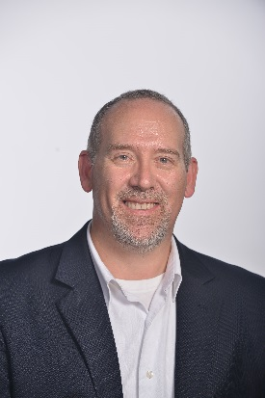**Jeff Hampton, Vice President of Operations**

**Travel Oregon**

Jeff Hampton is a member of the leadership team for the Oregon Tourism Commission, a semi-independent state agency doing business as Travel Oregon. Before taking on his current role, Jeff's professional focus was rooted in tourism policy and nonprofit leadership. For the past 20 years, he has had the pleasure of representing Oregon's travel and tourism industry before local, regional, state and federal policymakers, serving as director of regulatory affairs for the Oregon Restaurant Association, executive director of the Tri-County Lodging Association, president of the Oregon Lodging Association, and executive vice president of the Oregon Restaurant and Lodging Association. He continues his service to the industry through his current responsibilities as vice president of operations for Travel Oregon. As the state agency charged with inspiring travel to and throughout Oregon, Travel Oregon is one of 18 semi-independent agencies. Travel Oregon strives to create "a better life for Oregonians" and works to increase the positive economic impacts of tourism throughout the state.

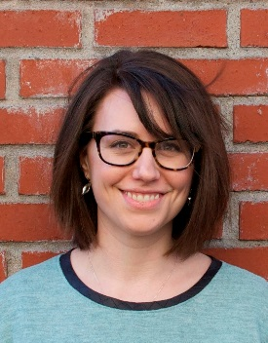****Anne Romens, Program Director****

****Arts Midwest****

Anne Romens oversees strategic planning, fundraising, communications and operations for Creating Connection, a national social change initiative that leverages the relationship between existing public values and arts and culture. A growing national movement seeking to shift the way in which arts, culture and creativity are recognized and valued in everyday life, Creating Connection is currently supporting arts leaders across the United States via training and technical assistance, network building, and knowledge sharing. Prior to her work on Creating Connection, Anne served as Arts Midwest's external relations manager for six years, where she supported fundraising and communications for the organization's portfolio of 10+ programs. Anne currently serves on the board of Sunshine Montessori School in Minneapolis. She holds a B.A. in political science from Loyola University Chicago and an M.A. in arts administration and policy from the School of the Art Institute of Chicago.

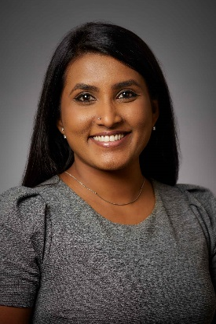**Feby Varghese, Special Project Manager**

**National Assembly of State Arts Agencies**

Feby Varghese joined the NASAA staff in 2017. As special projects manager, she supports and coordinates NASAA's arts advocacy efforts. She analyzes data to develop effective messages to share stories about the impact of the arts, and organizes on-line case making efforts toward federal support for the arts. Before joining NASAA, Feby founded an artist management company in India and led public relations initiatives for Sangeet Natak Akademi (National Academy of Performing Arts) under the Ministry of Culture in India. She has been a congressional fellow at the office of Congressman Jim McDermott. As a Fulbright scholar, she has two master's degrees, in arts management and English literature, and a postgraduate diploma in copywriting. Feby speaks more than five languages. As a cross-cultural arts manager, she has worked in three capital cities of the world.

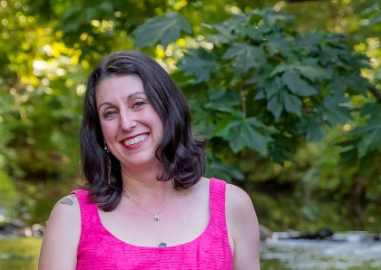**Deb Vaughn, Arts Education Coordinator**

**Oregon Arts Commission**

Deb Vaughn oversees the Oregon Arts Commission's education programs. In 2011, she successfully assembled a team for the National Endowment for the Arts's Education Leaders Institute, resulting in the passage of a bill allowing for proficiency based demonstrations of knowledge in Oregon schools. From 2013-2016, Deb oversaw the development and implementation of the Connecting Students to the World of Work grant, providing work-force development pathways for underserved students through mentorship programs. Deb developed a national accessibility model for students who are deaf participating in Poetry Out Loud. A trained singer, actor and writer, she has worked as a creative drama teacher in Oregon and Arizona. Deb received in 2009 a Sunburst Award from Young Audiences for her exemplary commitment to arts education, and again in 2012 for her arts education advocacy work. Born and raised in Oregon, Deb holds a nonprofit program evaluation certificate from Portland State University, a M.F.A. in theatre for youth from Arizona State University and a B.A. in theatre from University of Portland.

**Alison Watson, Programs Manager**

**Michigan Council for the Arts & Cultural Affairs**

Alison Watson is the programs manager for the Michigan Council for Arts & Cultural Affairs. She administers the Operational Support and Services to the Field programs, as well as providing support for all grant programs offered through the Council. Prior to joining the MCACA staff she worked at various nonprofit arts organizations on both local and state levels, including the Michigan Association of Community Arts Agencies, VSA Michigan and the Michigan Theatre of Jackson. Alison developed a passion for the arts at a young age and has worked to encourage an inclusive arts environment in Michigan ever since.

Friday, October 13

**Plenary Session: National Endowment for the Arts**

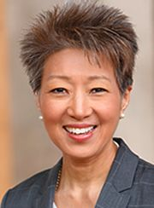**Jane Chu**

**Chairman, National Endowment for the Arts**

Jane Chu is the 11th chairman of the National Endowment for the Arts. With a background in arts administration and philanthropy, Chairman Chu is also an accomplished artist and musician. She leads a dedicated and passionate group of people to support and fund the arts and creative activities in communities across the nation. Chu was born in Shawnee, Oklahoma, and raised in Arkadelphia, Arkansas, the daughter of Chinese immigrants. She studied music growing up, eventually receiving bachelor's degrees in piano performance and music education from Ouachita Baptist University, and master's degrees in music and piano pedagogy from Southern Methodist University. Additionally, Chu holds a master's degree in business administration from Rockhurst University and a Ph.D. in philanthropic studies from Indiana University. In addition to awarding more than $377 million in grants during her tenure to date, Chu has issued new research reports on arts participation and the impact of the arts and cultural industries on the nation's gross domestic product; has made hundreds of trips to communities across the nation to see first-hand how the arts are impacting people and places; and launched the Tell Us Your Story project that demonstrates the importance of the arts in our lives. As part of the NEA's 50th anniversary, Chairman Chu launched her signature leadership initiative, [Creativity Connects](https://www.arts.gov/50th/creativity-connects), to investigate the current state of the arts in our nation and explore how the arts connect with other industries. From 2006 to 2014, Chu served as the president and CEO of the Kauffman Center for the Performing Arts in Kansas City, Missouri, overseeing a $413-million campaign to build the center. She was a fund executive at the Kauffman Fund for Kansas City from 2004 to 2006, and vice president of external relations for Union Station Kansas City from 2002 to 2004. Previously, she was vice president of community investment for the Greater Kansas City Community Foundation from 1997 to 2002.

Friday, October 13, continued

**Peer Sessions, Part II: Crisis Leadership**

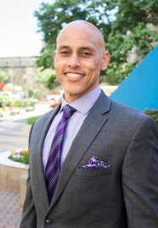**Dwayne Rumber, Chief Operating Officer**

**Elevated Leadership Development, LLC**

Dwayne Rumber is a creative training manager with more than 25 years of experience designing competency based leadership programs and instituting innovative solutions in the public sector. He is skilled in the facilitation of strategic planning, change management, customer service and team building workshops. Elevated Leadership Development provides tailored learning solutions to improve individual, team and organizational performance. Dwayne received his bachelor's degree from Texas Christian University, holds a master's degree from American University and is a graduate of Georgetown University's Leadership Coaching Certification Program.

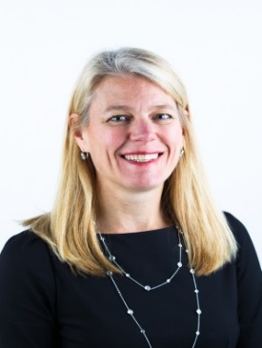**Alexis Feringa, Chief Operating Officer**

**Feringa Group, LLC**

Alexis Feringa provides executive coaching, strategic planning, facilitation and leadership development services to leaders in Fortune 50 corporations, law firms and nonprofits. Previously, she spent more than 20 years at Booz Allen Hamilton, the last six as vice president. She had P&L responsibility for businesses across intelligence community, Department of Defense and civil agency clients; her teams provided strategic planning, business planning, policy development, training and program management consulting services. Alexis holds a master's degree in international relations from The Fletcher School of Law & Diplomacy. She is a graduate of Georgetown University's Leadership Coaching Certification Program.

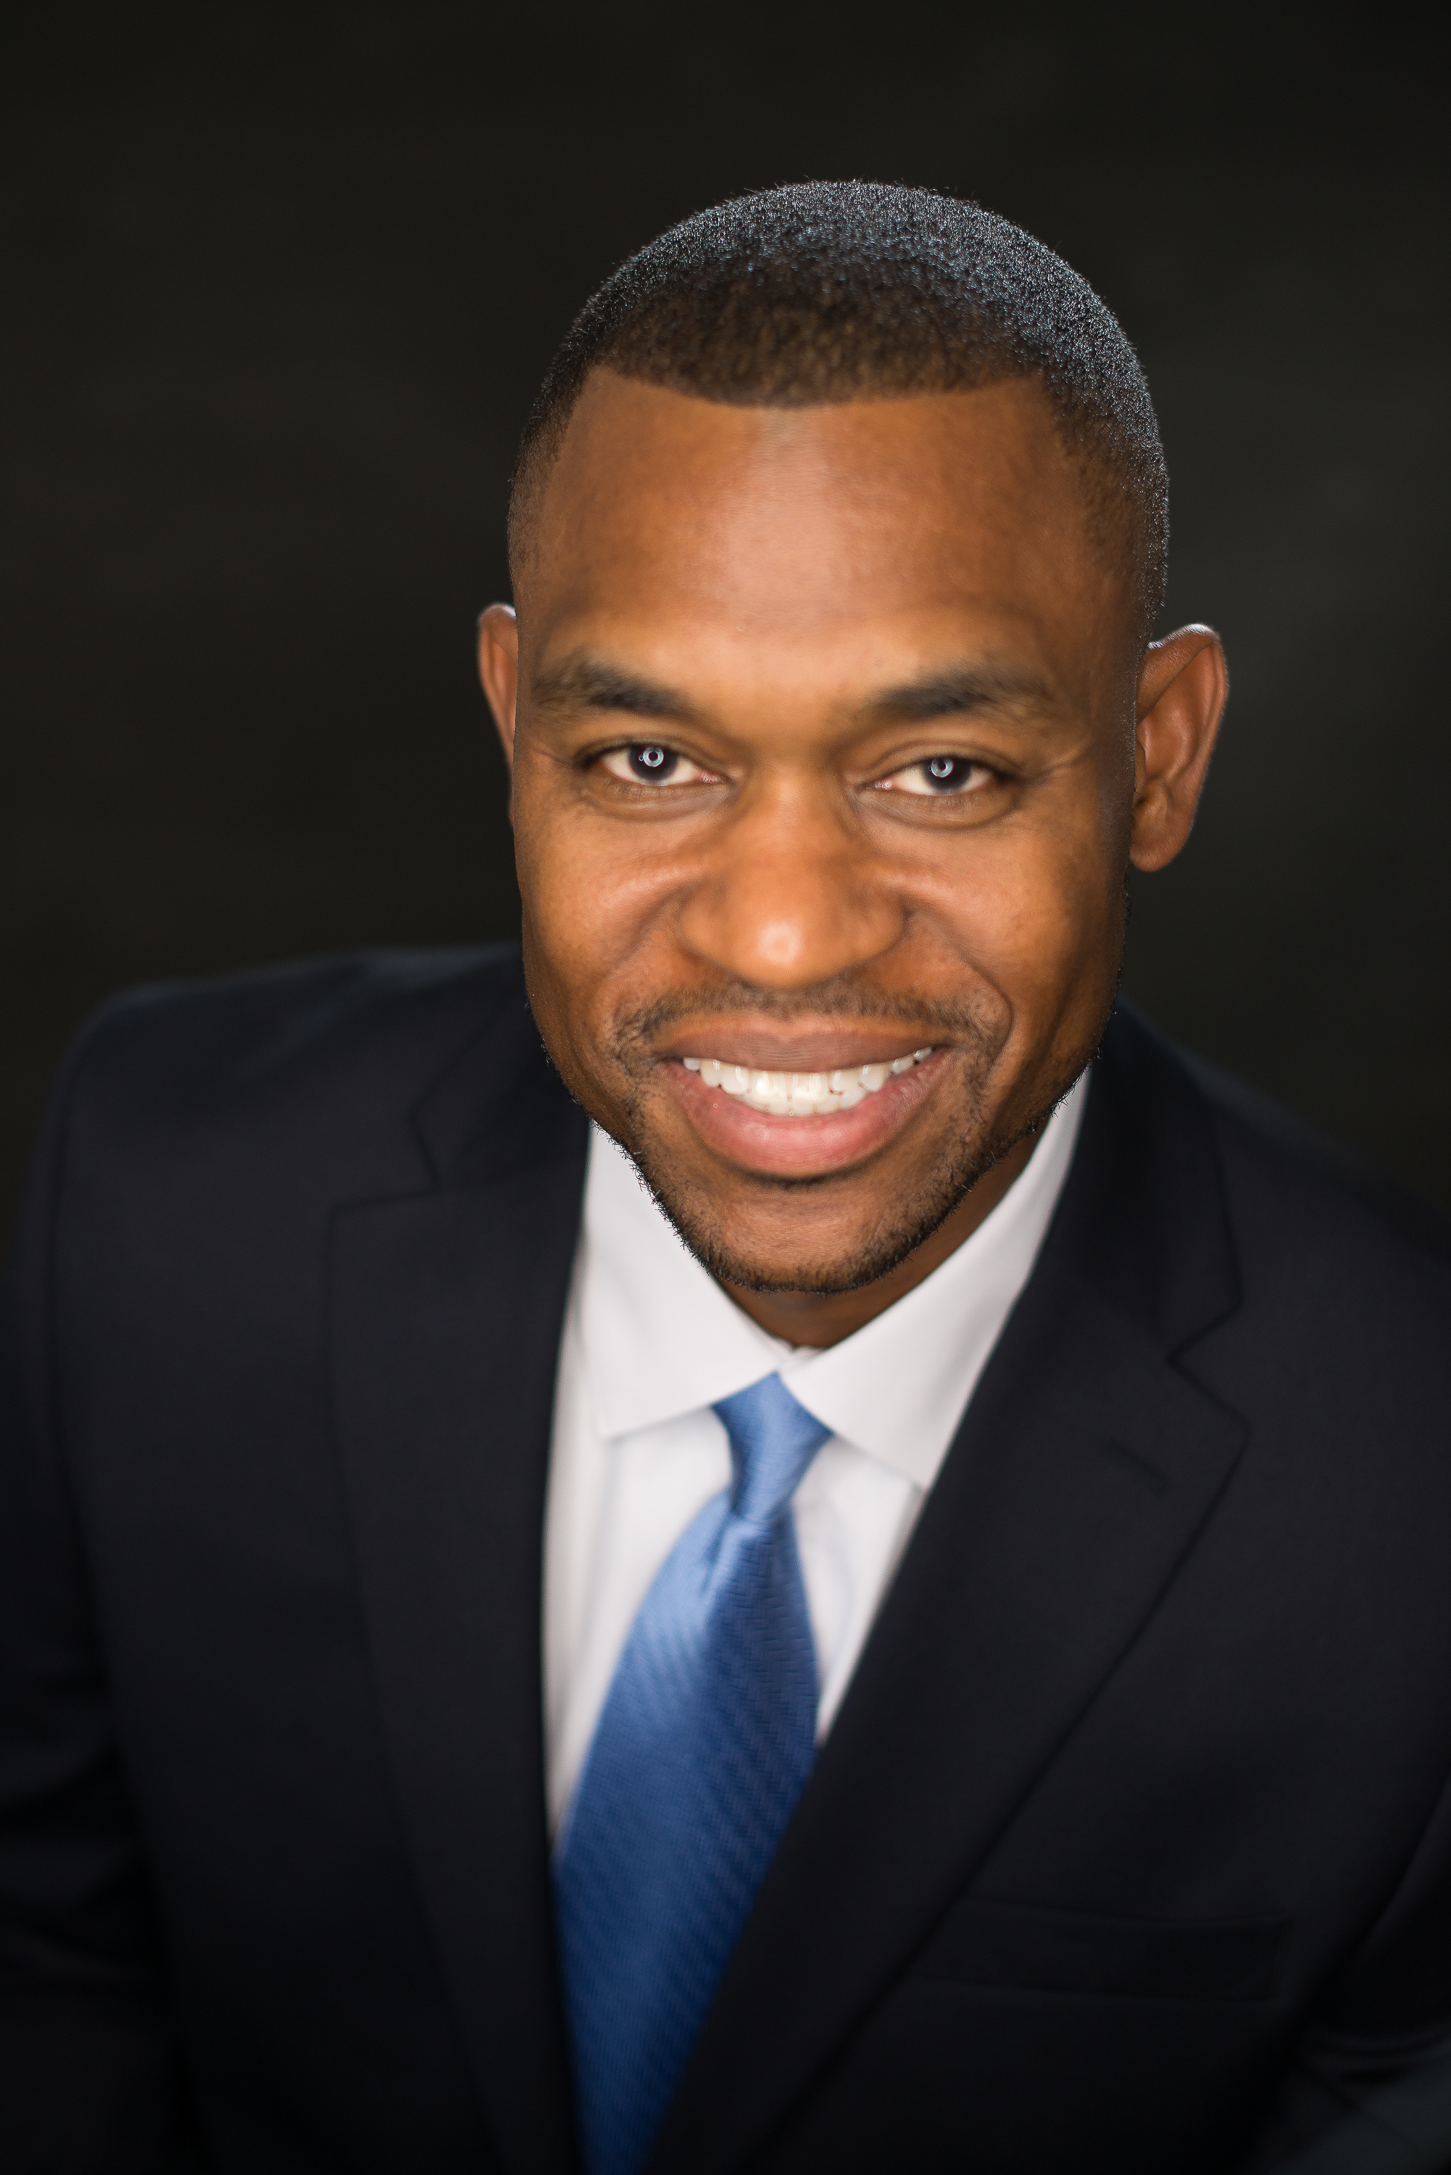**Michael Perry, Cofounder, President and Chief Operating Officer**

**Catalyst Executive Advising and Development, LLC**

Michael Perry is an accomplished leadership, human performance and behavioral health expert. A retired Army psychologist and career leader, Michael's consulting, training and coaching services cater to a wide array of organizations and leaders to include the full spectrum of public, private and nonprofit sectors. Michael holds a Ph.D. in clinical psychology and a master's degree in medical psychology from the Uniformed Services University of the Health Sciences in Bethesda, Maryland. He is a graduate of Georgetown University's Leadership Coaching Certification Program.