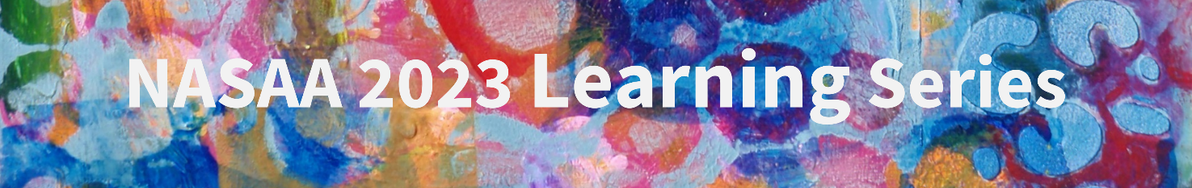

Untapped Opportunity: Older Americans & the Arts Web Seminar
December 6, 2022, 3:00 – 4:00 p.m. Eastern

Suggested Promotional Materials

Facebook Post
A free web seminar—December 6 at 3:00 p.m. Eastern—features new @CultureTrack research, a collaboration between @LaPlaca Cohen and @Slover Linett Audience Research and supported by @E.A. Michelson Philanthropy, exploring the cultural participation priorities and desires of older adults. This groundbreaking project yields actionable insights that can help organizations develop responsive and inclusive approaches to serving older adults. All are welcome! https://bit.ly/3FMWzIy

Tweet
A free web seminar—December 6, 3:00 p.m. Eastern—features new @CultureTrack research exploring actionable insights that can help organizations develop responsive and inclusive approaches to serving older adults. https://bit.ly/3FMWzIy @LaPlacaCohen @SloverLinett @EAMPhil

LinkedIn Post
A free web seminar—December 6, 3:00 p.m. Eastern—features new Culture Track research, a collaboration between @LaPlaca Cohen and @Slover Linett Audience Research, supported by @E.A. Michelson Philanthropy, exploring the cultural participation priorities and desires of older adults. The groundbreaking project yields actionable insights to help organizations develop responsive, inclusive approaches to serving older adults. All are welcome! https://bit.ly/3FMWzIy

Newsletter Blurb
A free web seminar from the National Assembly of State Arts Agencies, Untapped Opportunity: Older Americans & the Arts, explores new research about the priorities of older adults who engage with the arts. The seminar springs from a groundbreaking Culture Track report that suggests how organizations can develop responsive and inclusive strategies for serving older adults. The one-hour session is designed for arts nonprofits serving older adults, state and local government agencies, arts advocates, and organizations funding creative aging programs. All organizations that are pursuing arts based creative aging initiatives are welcome to participate as well. The web seminar takes place on December 6 at 3:00 p.m. Eastern. Register today. The report is a collaboration between LaPlaca Cohen and Slover Linett Audience Research, supported by E.A. Michelson Philanthropy.

The National Assembly of State Arts Agencies (NASAA) is the professional association of the nation’s 56 state and jurisdictional arts agencies. NASAA is a national, not-for-profit, nonpartisan organization that champions public support for the arts in America. The Older Americans & the Arts report is a collaboration between LaPlaca Cohen and Slover Linett Audience Research, supported E.A. Michelson Philanthropy.

